**Mockito exercises**

**Exercise 2: Verifying Interactions**

Scenario:

You need to ensure that a method is called with specific arguments.

Steps:

1. Create a mock object.

2. Call the method with specific arguments.

3. Verify the interaction.

Solution Code:

import static org.mockito.Mockito.*;

import org.junit.jupiter.api.Test;

import org.mockito.Mockito;

public class MyServiceTest {

@Test

public void testVerifyInteraction() {

ExternalApi mockApi = Mockito.mock(ExternalApi.class);

MyService service = new MyService(mockApi);

service.fetchData();

verify(mockApi).getData();

}

}

**IMPLEMENTATION IN ECLIPSE :**

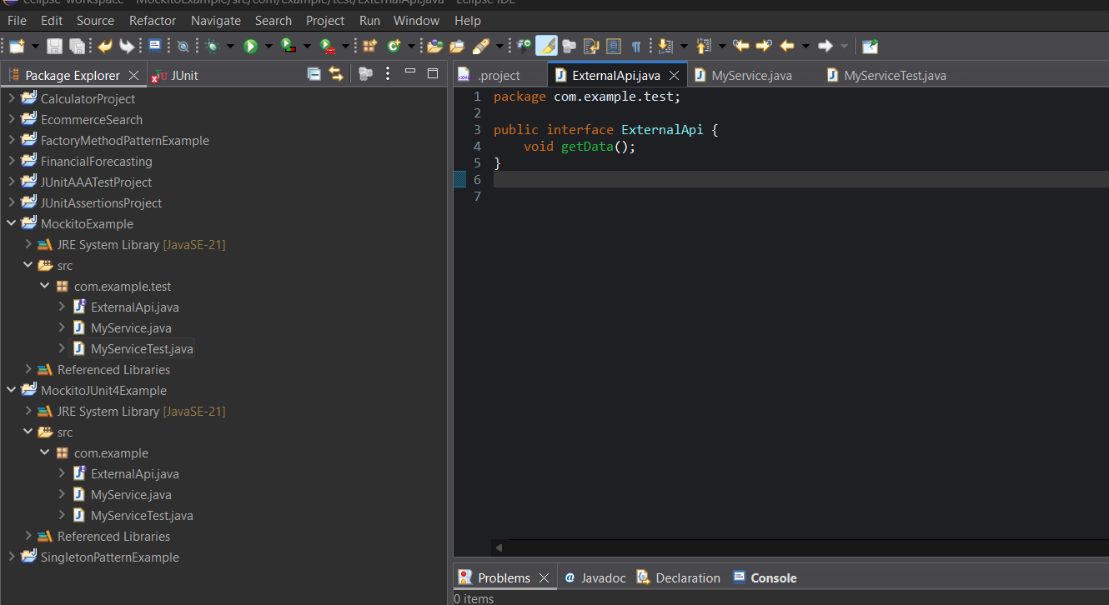

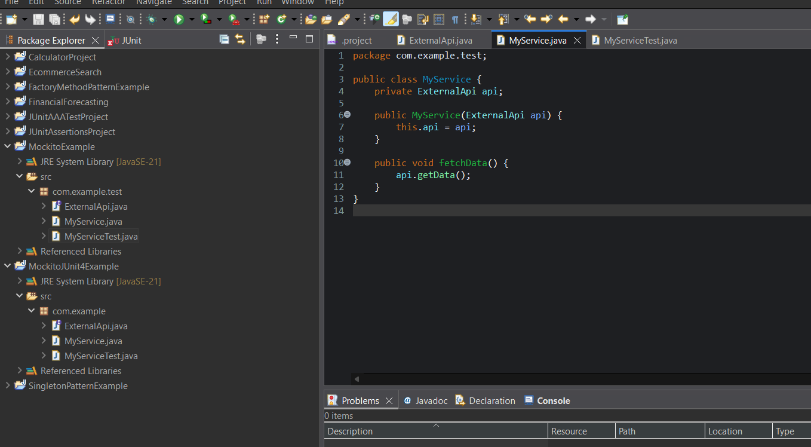

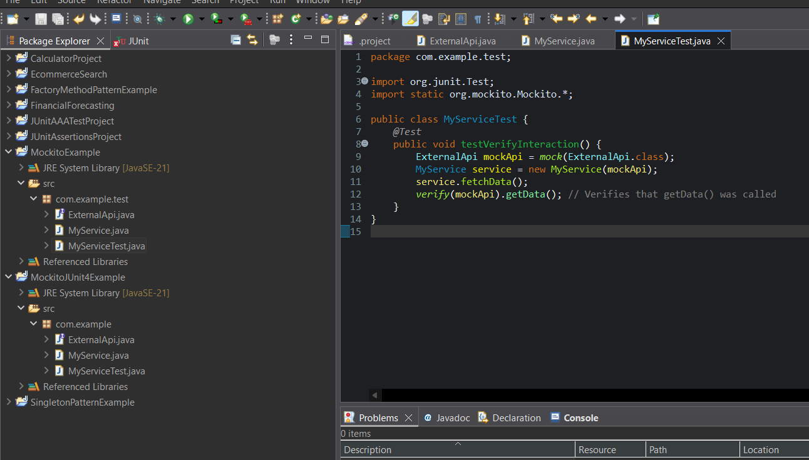

**OUTPUT :**

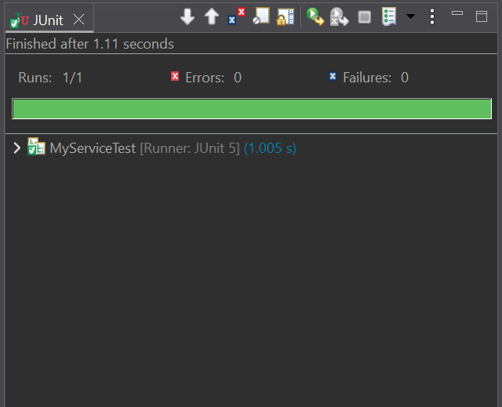

**PROGRAM :**

package com.example.test;

public interface ExternalApi {

void getData();

}

package com.example.test;

public class MyService {

private ExternalApi api;

public MyService(ExternalApi api) {

this.api = api;

}

public void fetchData() {

api.getData();

}

}

package com.example.test;

import org.junit.Test;

import static org.mockito.Mockito.*;

public class MyServiceTest {

@Test

public void testVerifyInteraction() {

ExternalApi mockApi = mock(ExternalApi.class);

MyService service = new MyService(mockApi);

service.fetchData();

verify(mockApi).getData(); // Verifies that getData() was called

}

}

**OUTPUT :**

